Azul Fuel Waste Reduction Project

Technical Report on Fleet Reassignment Screening

Eduardo Souza
Robert Sanabria
Burak Agar
Alexandre Machado

Team 5 | AE 398 Global Experience Brazil | May 2026

Observed operating sample: 2024-01-01 to 2025-11-15

1. Abstract and Research Contribution
This report presents a technical screening study of fuel waste reduction opportunities in Azul's mixed-fleet operation. The analysis is organized as a step-by-step screening funnel: first, the observed fleet and network are characterized; second, the relationships among distance, trip time, take-off weight, and fuel burn are examined; third, aircraft-specific efficient operating windows are defined; fourth, route-level interchangeability is tested only where aircraft families overlap in observed efficient operations; and fifth, capacity is checked so that a lower-fuel aircraft is not selected at the cost of materially reducing seat supply. Through this sequence, raw fuel data becomes a controlled operational comparison rather than a simple average-based aircraft ranking. Table 1 summarizes the core result.
Table 1 summarizes a narrow and operationally interpretable result. Among the tested substitution directions, E2-for-E1 is the clearest actionable opportunity, remaining fuel-positive after approximate seat supply is preserved. The final output is a route-priority list for validation, not a complete fleet optimizer or an automatic replacement rule.

Table 1. Core research result.
Metric | Value | Interpretation
Cleaned flight records | 288,107 | Analytical sample after validity filters.
Directional routes | 419 | Origin-destination route universe in the cleaned sample.
Airports | 113 | Distinct stations appearing as origin or destination.
E2-for-E1 priority routes | 7 | Route-level validation queue from sweet-spot overlap and capacity screening.
Observed E1 sweet-spot flights | 641 | Observed E1 flight equivalents used for the route-priority estimate.
Median equal-seat fuel saving | 26.8% | Median modeled saving after approximate seat supply is held constant.
Modeled fuel saving | 481,443 kg | Gross modeled fuel saving over equivalent observed seat supply, not annualized.
Source: Authors.

2. Introduction and Research Question
Fuel burn in airline operations is not a property of aircraft type alone. It is a joint outcome of aircraft family, stage length, trip time, payload, take-off weight, route structure, and departure frequency. For an airline operating a mixed fleet, this creates a methodological problem: aircraft cannot be ranked by raw fuel burn unless they are compared under similar operating conditions. The practical goal is therefore to move from broad fleet description to a controlled comparison of aircraft that actually operate in similar mission spaces.
The research question is: how can Azul identify route-level aircraft reassignment candidates that reduce avoidable fuel burn while remaining inside the observed operating envelope of the candidate aircraft families?
The study treats fuel waste as the difference between observed fuel burn and the modeled fuel burn of a feasible alternative aircraft assignment under comparable mission conditions. The word feasible is used in a screening sense: the model tests observed route overlap and approximate seat supply, but it does not model tail rotations, crew availability, maintenance checks, gate constraints, airport infrastructure, or route economics.

3. Data Sources and Analytical Sample
The analysis uses two workbooks and one cleaned analytical table generated from the source files. Azul_DataSample.xlsx provides flight-level operations. Azul_Project_Data_2.xlsx provides load-evidence averages joined as passenger and payload proxies. The cleaned table consolidates valid operating records, derived efficiency measures, and route-level fields used throughout this report. Table 2 identifies each input and shows how raw operating data becomes the basis for the fleet reassignment screen.

Table 2. Data sources used in the analytical workflow.
Source or output | Scope | Analytical role
Azul_DataSample.xlsx | 288,337 raw flight records | Primary operating data: date, route, flight number, aircraft family, fuel kg, TOW kg, trip time, and distance.
Azul_Project_Data_2.xlsx | 8,864 load-evidence records | Passenger, passenger weight, zero-fuel weight, dry operating weight, cargo, and baggage proxies.
Cleaned analytical table | 288,107 cleaned and joined records | Main analytical table used for fleet profiling, derived variables, and route-level screens.
Report analytical workflow | Self-contained methodological sequence | Exploratory profile, correlations, sweet spots, behavior-based grouping, route interchangeability, and capacity logic.
Source: Authors.
Cleaning is intentionally conservative. The goal is not to reshape the dataset but to remove observations whose denominators or physical values make efficiency measures unreliable. Table 3 reports the cleaning outcome and shows that 99.92% of records were retained, meaning the analysis is based on the original operating pattern rather than on a heavily filtered subset.

Table 3. Cleaning outcome.
Cleaning step | Rows removed or count
Initial rows after required fields | 288,337
Nonpositive fuel removed | 4
Trip time below 600 seconds removed | 29
Implausible fuel per NM removed | 1
Implausible ground speed removed | 196
Final analytical rows | 288,107
Records retained | 99.92%
Source: Authors.

4. Analytical Variables and Derived Metrics
The analysis converts operational fields into comparable measures of mission profile and fuel intensity. The central denominator is nautical miles, using the GroundDistance [NM] and TripFuelBurnTotal [KG] fields available in the source data. Table 4 defines the variables used in the report and clarifies whether each variable describes the mission, ranks fuel efficiency, defines a sweet spot, or tests capacity feasibility.

Table 4. Variable definitions.
Variable | Definition | Use in analysis
Equipment | Aircraft family label: ATR, E1, E2, A320, or A321. | Defines fleet groups, operating regimes, and substitution directions.
Route | Directional origin-destination pair. | Defines the route unit for overlap and priority screens.
Distance NM | Ground distance in nautical miles. | Stage-length control and denominator for kg/NM.
Trip time | TripTimeSec converted to minutes. | Mission-duration control and sweet-spot dimension.
Fuel kg | TripFuelBurnTotal [KG]. | Primary fuel outcome.
TOW kg | TakeOffWeight [KG]. | Operational proxy for aircraft size, payload, fuel uplift, and mission behavior.
Fuel per NM | Fuel kg divided by distance NM. | Primary fuel-intensity measure used to rank efficient observed flights.
Passenger proxy | AVG_PassengerTotal joined from load evidence. | Contextual load signal, not true flight-level demand.
Seat proxy | Fixed assumed family seats: ATR 70, E1 118, E2 136, A320 174, A321 214. | Equal-seat feasibility screen.
Joint sweet spot | Flight inside efficient IQR windows for distance, trip time, and TOW. | Comparable operating sample for route substitution tests.
Source: Authors.
Fuel intensity is defined as FuelPerNM_i = FuelKg_i / DistanceNM_i. By normalizing fuel burn by distance, the metric avoids favoring shorter flights and penalizing longer flights when the aircraft is operating efficiently for its assigned mission. Equal-seat fuel saving is computed by estimating how many flights of the proposed aircraft would be required to provide the same approximate seat supply as the observed worse-aircraft sweet-spot flights. The capacity adjustment prevents a substitution from looking attractive simply by using a smaller aircraft with fewer seats.

5. Exploratory Fleet and Network Profile
The analysis starts with a descriptive fleet profile. Before testing substitutions, the observed mission structure must be clear. Table 5 shows that the cleaned sample is a stratified fleet: ATR aircraft concentrate on shorter sectors; E1 and E2 aircraft occupy the regional-jet space; and A320/A321 aircraft operate longer, denser missions. The profile separates aircraft families that are potentially comparable from comparisons that would be misleading.

Table 5. Fleet profile in the cleaned sample.
Aircraft | Flights | Unique routes | Median distance (NM) | Median trip time (min) | Median TOW (kg) | Median fuel kg/NM
ATR | 78,452 | 220 | 231.0 | 62 | 21,225 | 2.96
E1 | 44,805 | 269 | 295.6 | 53 | 44,429 | 6.67
E2 | 50,191 | 260 | 382.4 | 64 | 52,745 | 4.98
A320 | 100,865 | 294 | 889.2 | 128 | 66,644 | 5.38
A321 | 13,794 | 96 | 1,170.4 | 167 | 80,116 | 6.01
Source: Authors.

Raw fleet averages cannot support direct aircraft ranking on their own. An A321 burns more fuel than an ATR largely due to its different mission class. The relevant analytical comparison is not global fleet average versus global fleet average; it is aircraft performance inside an overlapping and operationally plausible route-mission space.

6. Correlation Structure and Mission Drivers
The correlation analysis establishes the basic functional structure of the data. Table 6 shows that fuel burn is strongly related to distance and trip time across all major equipment families. TOW is also relevant, although its relationship with fuel is more dispersed as it reflects aircraft family and route assignment as well as payload. Figure 1 visualizes these relationships and supports the decision to control for mission conditions before comparing fuel performance.

Table 6. Equipment-level correlations with fuel burn.
Aircraft | Fuel vs TOW | Fuel vs trip time | Fuel vs distance | Interpretation
A320 | 0.64 | 0.99 | 0.98 | Fuel burn is dominated by stage length and duration.
A321 | 0.72 | 0.96 | 0.94 | Longer missions and heavier operations move together.
ATR | 0.33 | 0.98 | 0.98 | Short-haul fuel burn is primarily explained by distance and time.
E1 | 0.35 | 0.98 | 0.98 | Distance and time dominate within the regional-jet mission band.
E2 | 0.51 | 0.95 | 0.95 | Fuel burn scales with mission length, with moderate TOW association.
Source: Authors.
Figure 1. Mission-driver relationships by aircraft family.
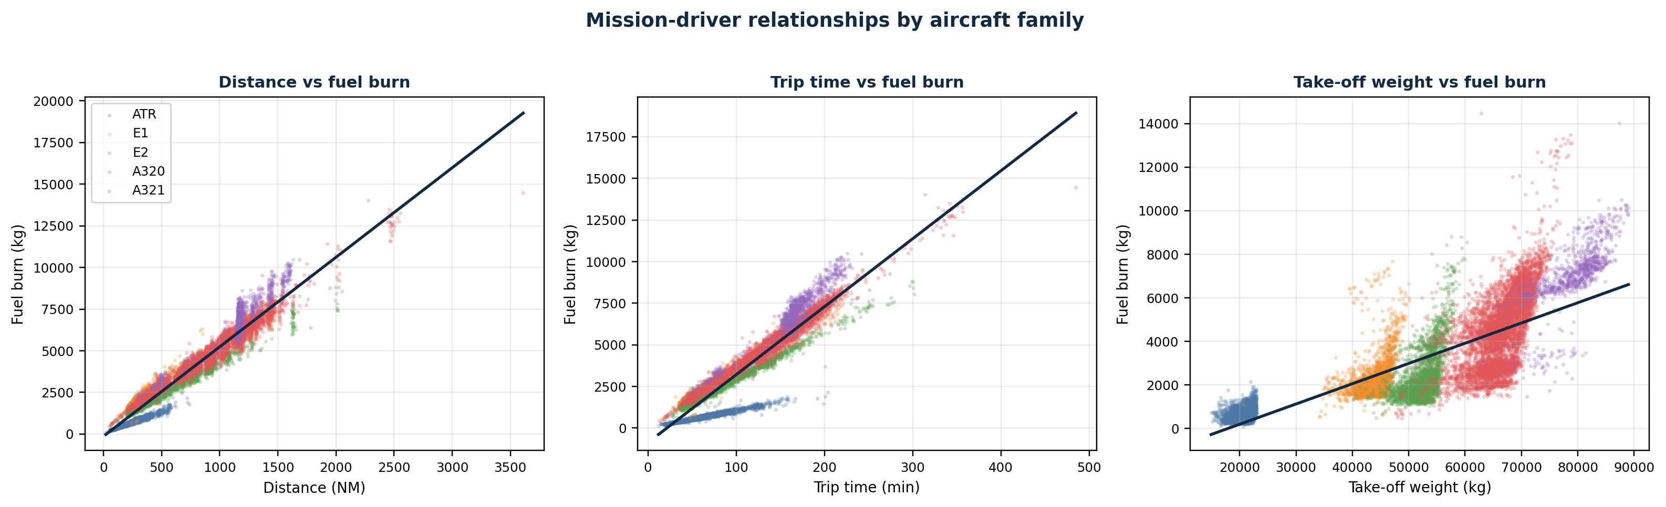
Source: Authors.
Figure 1 shows tight, positive relationships between fuel burn, distance, and trip time. Take-off weight adds operational context but is more dispersed, reflecting both payload and aircraft-family assignment. The later screens therefore control for mission conditions before comparing aircraft.

The substitution screen is therefore built around comparable mission conditions, so route length, duration, and assignment patterns are not mistaken for aircraft performance.

7. Operating Regimes by Take-off Weight
The next analytical step uses take-off weight to construct observed operating regimes. TOW is not a perfect measure of demand, but it is a useful operational proxy for the combined effect of airframe, fuel uplift, passengers, baggage, cargo, and mission planning. Table 7 summarizes the low, median, and high TOW bands by aircraft family, while Figure 2 translates those bands into a visual operating ladder.
Table 7. Observed TOW regimes.
Aircraft | Flights | Low TOW (kg) | Median TOW (kg) | High TOW (kg)
ATR | 78,452 | 18,948 | 21,225 | 22,305
E1 | 44,805 | 40,868 | 44,429 | 46,299
E2 | 50,191 | 49,129 | 52,745 | 55,191
A320 | 100,865 | 61,142 | 66,644 | 70,963
A321 | 13,794 | 72,751 | 80,116 | 84,299
Source: Authors.

Figure 2. Observed take-off-weight regimes by aircraft family.
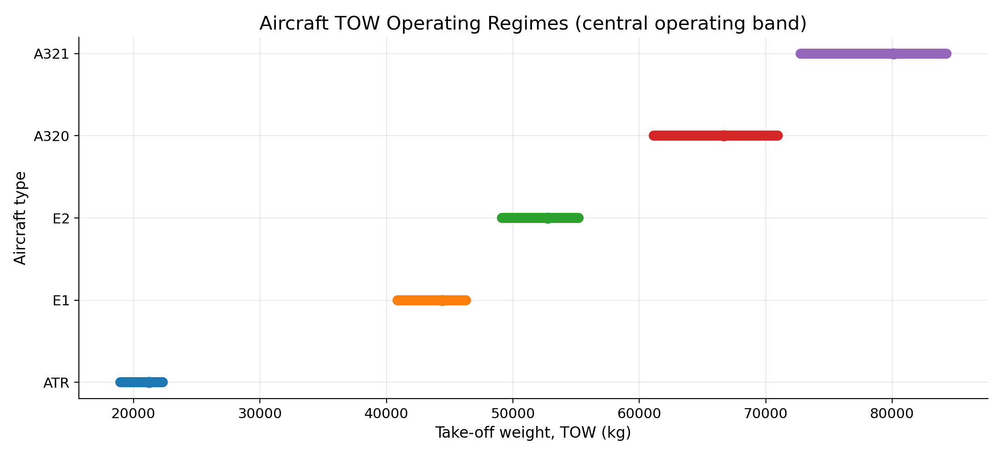
Source: Authors.

Figure 2 shows that the regimes form an ordered mission ladder. Using within-family efficient windows before cross-family comparison keeps the baseline anchored in each aircraft's own observed operating domain. Only after that baseline is established is overlap with another aircraft family tested.

8. Sweet-Spot Methodology
The sweet-spot methodology is the main methodological bridge between exploratory analysis and substitution screening. Within each aircraft family, flights are ranked by fuel per NM. The best-performing 50 percent define the family's observed efficient operating subset. Interquartile windows are then calculated for distance, trip time, and TOW within that subset. Table 8 reports the resulting efficient operating windows and the number of joint sweet-spot flights retained for each aircraft family.
A flight is classified as a joint sweet-spot observation only if it falls simultaneously inside all three windows: distance, trip time, and TOW. In other words, the flight is not just fuel-efficient in isolation; it is fuel-efficient within a typical efficient mission profile for that aircraft family. The distributional approach avoids imposing a linear fuel curve and reduces the influence of tail observations.

Table 8. Efficient operating windows from the best-performing 50 percent of flights.
Aircraft | Best-half flights | Joint sweet flights | Distance IQR (NM) | Trip time IQR (min) | TOW IQR (kg) | Joint median fuel kg/NM
ATR | 39,228 | 14,574 | 221.0 to 321.0 | 60.0 to 86.0 | 19,770 to 21,828 | 2.87
E1 | 22,403 | 7,632 | 308.3 to 482.3 | 53.0 to 78.0 | 42,289 to 45,681 | 6.33
E2 | 25,096 | 9,039 | 440.5 to 839.6 | 68.0 to 129.0 | 51,130 to 54,603 | 4.67
A320 | 50,433 | 15,701 | 888.6 to 1,187.6 | 126.0 to 168.0 | 64,059 to 68,882 | 5.08
A321 | 6,897 | 1,958 | 1,156.1 to 1,198.6 | 158.0 to 173.0 | 74,915 to 80,178 | 5.81
Source: Authors.
The sweet-spot construction uses four variables with different roles. Fuel per nautical mile is the ranking variable, normalizing fuel burn by stage length and identifying the efficient half of each aircraft family. Distance, trip time, and take-off weight are the operating-window variables, describing whether two flights are operationally comparable. Figure 3 summarizes these aircraft-specific windows and shows the distance, trip-time, and TOW ranges that define each family's efficient mission band.
Quartiles are used to identify the central operating band without imposing a single linear fuel curve. The first and third quartiles define that band inside the efficient subset, reducing the influence of extreme records, atypical missions, and operational tails. The joint sweet spot is therefore a conservative definition: a flight must be efficient and must sit within the central efficient operating band of its own aircraft family. The method supports screening decisions without claiming to be a full physical fuel-burn model.
Figure 3. Efficient operating windows used to define aircraft-specific sweet spots.
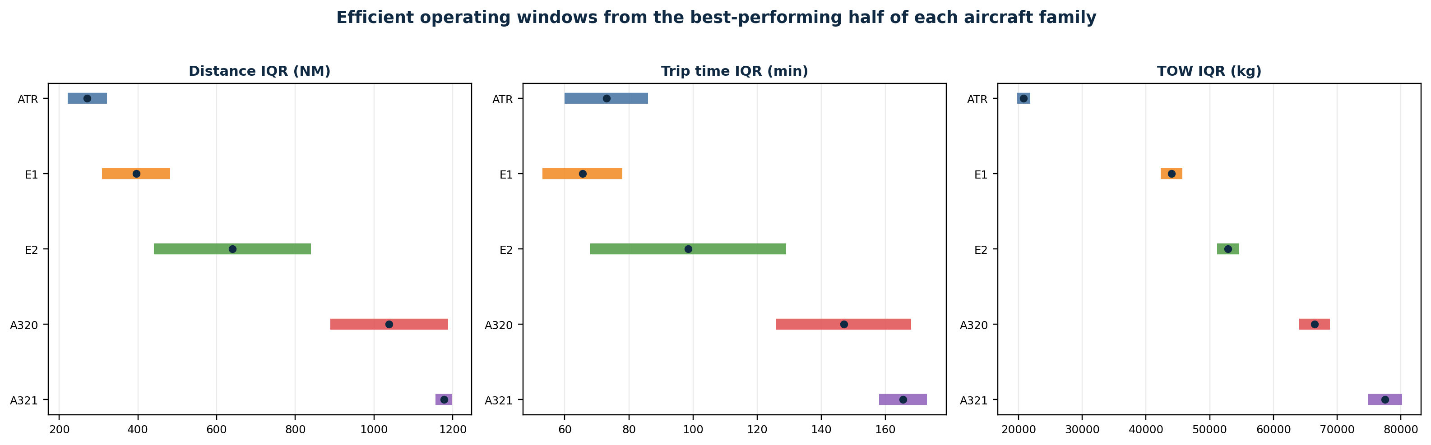
Source: Authors.
Figure 3 reinforces the need to evaluate each aircraft family within its own operating domain. ATR concentrates on short missions, E1 and E2 occupy the regional-jet range, and A320/A321 sit higher on the mission ladder. The analysis therefore avoids treating a long-haul narrowbody flight and a short-haul turboprop flight as comparable only on the basis that both appear in the same fleet dataset.
Figure 4. Joint sweet-spot observations in the E1 and E2 regional-jet space.
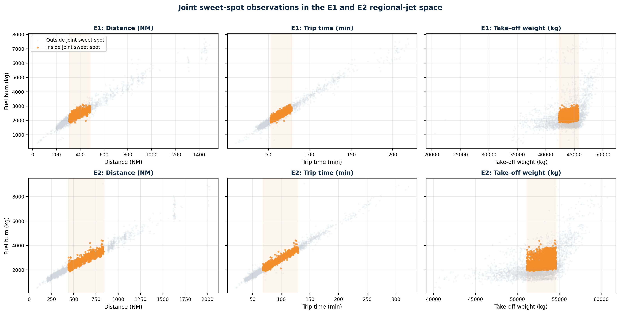
Source: Authors.
Figure 4 highlights the regional-jet sweet-spot overlap used for the final route screen. The highlighted points are not merely the lowest-fuel observations. They are flights that simultaneously fall within the efficient distance, trip-time, and TOW windows for their own aircraft family. The final route test focuses on E2-for-E1 overlap, where the regional-jet pair provides an observed comparison space with missions close enough to test substitution.

9. Joint Sweet-Spots and Behavior-Based Fleet Clusters
After sweet-spot construction, aircraft families are grouped according to observed mission profile, efficient mission profile, fuel intensity, and fuel-distance behavior. Table 9 summarizes the resulting behavior-based groups. The grouping tests whether aircraft families are naturally comparable before any substitution is proposed. In practical terms, it asks whether the aircraft are being used for similar types of missions, not just whether they appear in the same airline fleet.

Table 9. Behavior-based fleet group interpretation.
Group | Aircraft families | Analytical interpretation
Short-haul turboprop missions | ATR | Distinct short-stage operating curve; not naturally interchangeable with jets without a capacity and frequency penalty.
Short to medium regional-jet missions | E1 and E2 | Most relevant substitution space because both families operate in overlapping regional and medium sectors.
Medium to long-haul narrowbody missions | A320 and A321 | Comparable narrowbody group, but capacity differences are material.
Source: Authors.

The group structure in Table 9 supports the final focus on the regional-jet pair. E2 is not treated as universally superior; rather, it is treated as a candidate where the observed E1 and E2 route-mission spaces overlap.

10. Route Interchangeability Screen
The route interchangeability screen applies the joint sweet-spot definition at route level. A candidate comparison is retained only when both aircraft families are observed on the same route inside their own sweet spots. The screen is deliberately conservative, testing substitutions from observed operating evidence rather than hypothetical aircraft deployment. Table 10 presents the fuel-only screen and separates the first fuel signal from the later capacity decision.

Table 10. Fuel-only route interchangeability screen.
Fuel-only direction | Candidate routes | Worse-aircraft sweet-spot flights | Median kg/NM saving | Interpretation
A320 replacing A321 | 4 | 1,957 | 14.6% | Fuel-positive before capacity is held constant.
ATR replacing E1 | 7 | 459 | 57.5% | Large per-flight fuel signal, but likely capacity constrained.
E2 replacing E1 | 7 | 641 | 17.7% | Moderate fuel signal in the regional-jet overlap space.
Source: Authors.

Table 10 should be read as an intermediate screen, not as the decision rule. It identifies possible directions for substitution, but it does not yet account for the number of seats supplied by each aircraft family. Without this distinction, a smaller aircraft can look fuel-efficient per flight while requiring more departures to move the same approximate number of seats.

11. Equal-Seat Capacity Screen
The capacity screen converts fuel-only comparisons into an approximate equal-seat comparison. The method attaches fixed seat proxies to each family and estimates the number of alternative-aircraft flights required to provide the same observed seat supply. The screen works as a proxy for capacity feasibility, not as a passenger-demand model. Table 11 reports the capacity-screen result by substitution direction, and Figure 5 shows which direction remains attractive after seat supply is preserved.

Table 11. Capacity-screen result by substitution direction.
Substitution | Routes | Median extra flights | Median equal-seat saving | Capacity-screen conclusion
E2 replacing E1 | 7 | 0.0% | 26.8% | Retained. Fuel-positive and no additional frequency required under the seat proxy.
ATR replacing E1 | 7 | 68.6% | 33.5% | Not retained. Requires substantial additional frequency to preserve seat supply.
A320 replacing A321 | 4 | 23.0% | -4.6% | Not retained. Turns fuel-negative once approximate seat supply is held constant.
Source: Authors.
Figure 5. Capacity-screen result after preserving approximate seat supply.
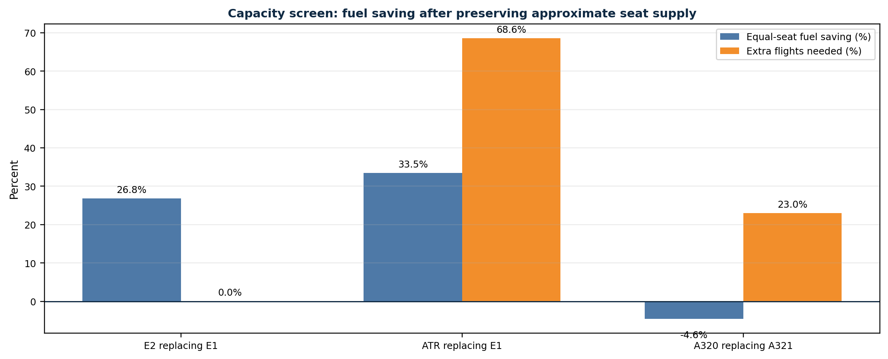
Source: Authors.
Figure 5 clarifies the difference between a fuel-only signal and a feasible substitution signal. ATR-for-E1 remains fuel-positive in isolation but requires substantial extra frequency, while A320-for-A321 turns negative after capacity is held constant. E2-for-E1 is retained by combining lower fuel intensity with no additional frequency requirement under the seat proxy.
The E2-for-E1 result survives the screen with a higher assumed E2 seat count than E1 and lower observed E2 fuel intensity in the retained overlap routes. E2-for-E1 is therefore the only tested direction that passes both fuel and capacity screens.

12. Route Priorities
The final analytical step is the route-priority stage. Table 12 lists the seven routes proposed as a validation queue for Azul's technical and scheduling review. They are not automatic reassignment instructions, and they should be evaluated with tail rotations, crew, maintenance, airport, payload, and economic constraints before implementation.

Table 12. E2-for-E1 route validation priorities.
Route | Observed E1 sweet flights | Median distance (NM) | Median equal-seat saving | Kg per E1 flight equivalent | Modeled kg saved
CGR -> VCP | 196 | 459.1 | 27.6% | 719 | 140,938
BSB -> VCP | 155 | 463.2 | 30.3% | 825 | 127,893
VCP -> BSB | 160 | 451.2 | 28.1% | 753 | 120,441
GYN -> VCP | 66 | 445.3 | 26.8% | 712 | 46,979
VCP -> IGU | 21 | 456.0 | 26.5% | 728 | 15,279
VCP -> CGR | 20 | 474.4 | 26.6% | 758 | 15,152
IOS -> CNF | 23 | 439.2 | 24.5% | 642 | 14,761
Total / median | 641 | - | 26.8% | 751 | 481,443
Source: Authors.

Table 12 is best interpreted as prioritization under uncertainty. The route list identifies where E2 allocation is expected to have the strongest fuel benefit within the observed regional-jet overlap space. It does not replace Azul's operational planning systems and does not model network-wide fleet assignment.

13. Conclusion Analysis
The analysis concludes that Azul's strongest tested opportunity is not a broad aircraft replacement rule but a targeted E2-for-E1 validation queue. The method first established fleet mission profiles, then normalized fuel burn by distance, then used distance, trip time, and take-off weight to define aircraft-specific efficient operating windows. It then tested only observed route overlaps and finally applied an equal-seat capacity screen. Through this sequence, raw fuel data is transformed into a controlled operational comparison rather than an aircraft comparison based on simple averages.
Among the tested directions, E2 replacing E1 is the only candidate that survives both screens. ATR replacing E1 shows a strong fuel-only signal, but it requires materially more frequency to preserve seat supply. A320 replacing A321 looks positive before capacity is considered but becomes negative after the equal-seat adjustment. E2 replacing E1 remains positive with more seats than the E1 and lower fuel intensity in the retained overlap routes.
The recommended next step is to validate the seven E2-for-E1 routes with Azul's scheduling, maintenance, crew, airport, payload, and commercial constraints, using this report as a focused screening layer before operational implementation.

